SDSN
February 3, 2019
First Draft
For Discussion Purposes

Understanding and Achieving the Sustainable Development Goals:
The Role of Multi-Religious Action

Part I. Introducing the Sustainable Development Goals

Transforming Our World: Agenda 2030 for Sustainable Development, containing the 17 Sustainable Development Goals (SDGs), Figure 1, was adopted by all UN member states in September 2015 for the 15-year period 2016-2030. The SDGs are the world’s agreed goals to achieve sustainable development by 2030. In the context of Agenda 2030, sustainable development means the simultaneous fulfillment of economic rights, social inclusion, and environmental sustainability. Agenda 2030 offers a detailed text that explains the purposes of sustainable development and the conceptual framework of the SDGs.

Economic Rights

From almost the start of the United Nations, and specifically with the adoption of the Universal Declaration of Human Rights in 1948, the world’s governments have recognized the basic rights of all people, including political, civil, economic, social, and cultural rights. The Universal Declaration stands as the “moral charter” of the UN. It has given rise to a vast international law, including treaties, case law, UN General Assembly resolutions, and initiatives such as the Millennium Development Goals (during 2001-2015) and the SDGS (during 2016-2030).

Economic rights are a subset of human rights. Most economic rights are reflected in the SDGs. Key economic rights, and associated SDGs, are the following.
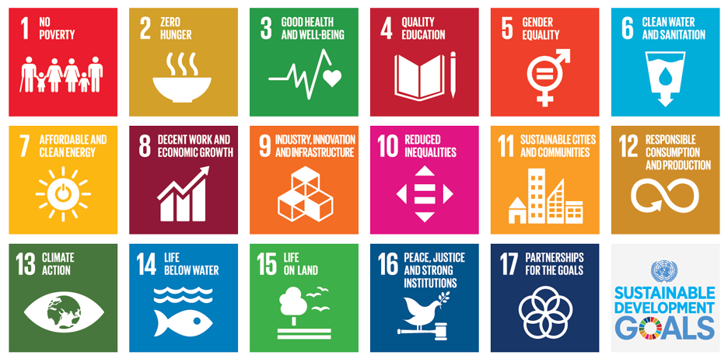
Figure 1. The 17 Sustainable Development Goals

Economic Rights:
- Right to an Adequate Standard of Living (SDG 1)
- Right to Social Security (SDG 1)
- Right to Food (SDG 2)
- Right to Health (SDG 3)
- Right to Education (SDG 4)
- Right to Safe Water and Sanitation (SDG 6)
- Right to Safe and Modern Energy (SDG 7)
- Right to Decent Work (SDG 8)
- Right to Development (SDG 9)
- Right to Decent Housing (SDG 11)

Social Inclusion

Social inclusion means not only social security and social insurance but also rights to fairness and justice of vulnerable groups within society. Social inclusion is part and parcel of the SDGs, including the following:

- Gender equality (SDG 5)
- Reduced Inequality of Income and Wealth (SDG 10)
- Right to Freedom from Violence (SDG 16)
- Right to Equal Access to Justice (SDG 16)
- Rights of Vulnerable Groups to Land and other Protections (SDG 2)

The goal to reduce income inequality (SDG 10) is notable. While the UN and international law have not defined a fair distribution of income, the high and rising inequality of wealth and income in the world today led the adoption of SDG 10 calling for a reduction of inequality among and within nations. Agenda 2030 notes that governments should assess inequalities according to “gender, age, race, ethnicity, migratory status, disability, geographic location and other characteristics relevant in national contexts.”

The SDGs give special attention to vulnerable groups, including women and children, migrants, racial and ethnic minorities, the disabled, the geographically isolated, and indigenous groups. Vulnerable groups are often poor and often lack access to justice. The property, rights as citizens, and physical persons are often subjected to violence and abuse.

Environmental Sustainability

When Universal Declaration was agreed in 1968 and key covenants on civil, political, economic, social, and cultural rights were agreed in the 1960s, there was still very little diplomatic focus on the growing costs and risks of human-induced environmental degradation. The first global conference on the environment was the UN Conference on the Human Environment (UNCHE) in Stockholm in 1972. This was followed by the Brundtland Commission in 1987 that first gave the world’s governments the concept of sustainable development, and then by the Rio Earth Summit in 1992 (known formally as the UN Conference on Environment and Development, UNCED).

The Rio Earth Summit agreed on three major treaties, the UN Framework Convention on Climate Change (UNFCCC), the Convention on Biological Diversity (CBD), and the UN Convention to Combat Desertification (UNCCD). The UNFCCC aimed to stop human-induced global warming in order to avoid “dangerous anthropogenic [human-caused] interference in the climate system.” The CBD aimed to stop the massive loss of Earth’s biodiversity. The UNCCD aimed to stop the degradation of dry lands, known as desertification.

When the UN member states enthusiastically adopted the three multilateral environmental agreements (MEAs) at the Rio Earth Summit, it seemed that sustainable development had arrived as a guiding principle for global diplomacy. Yet it was not to be. None of the three treaties was actually implemented in a serious way in the ensuing years.

When the treaties came up for a 20-year review in 2012, at a UN conference known as Rio+20, the considered technical view was that all three treaties had failed utterly to change the world’s reckless course towards global warming, species extinction, desertification (or degradation) of dry lands, and other environmental harms. It was the failure of the three treaties to be put in practice that motivated the Government of Colombia to recommend to the UN member states the adoption of Sustainable Development Goals to help get the world on track to head off environmental disaster, and to do so in a context of economic rights and social inclusion.

As of 2015, when the SDGs were adopted, the UN member states had identified three main categories of human-induced environmental disaster: climate change (global warming), destruction of biodiversity and habitats (including freshwater depletion), and pollution of the air, sea, and water from various industrial activities.

The SDGs therefore address the environmental threats facing the planet mainly in the following areas:

- Sustainable farm practices (SDG 2)
- Sustainable water management (SDG 6)
- Sustainable cities and other human settlements (SDG 11)
- Sustainable consumption and production (SDG 12)
- Stopping human-induced climate change (SDG 13)
- Protecting Earth’s marine ecosystems and biodiversity (SDG 14)
- Protecting Earth’s terrestrial ecosystems and biodiversity (SDG 15)

In general, these various goals are to be met through a combination of introducing new technologies (such as the shift from fossil fuels to renewable energy), changing behavior (such as healthier diets that are also better for the environment), and improving regulations and enforcement (such as improved design and enforcement of anti-pollution laws, over-fishing regulations, limits on logging rights, protection of endangered species, and other environmental challenges).

Part II. Implementing the SDGs

The SDGs are a set of goals, not a plan of action. They are part of a UN General Assembly Resolution rather than a legally enforceable treaty. In this sense, they are meant to be a tool for guidance, advocacy, and accountability, rather than a specific set of enforceable actions. And it is worth noting that even legally enforceable UN treaties are very often not enforced in practice.

One can say that the SDGs are part of a long UN agenda dating back to the 1960s to implement the Universal Declaration of Human Rights, partly through treaties, but mostly through global goals. The first of these was the Decade of Development (1960-70) that put the UN member states on record calling for successful development of the poorer nations, including the newly decolonized nations. This was followed by the Second Decade of Development (1971-80), the Third Decade of Development (1981-1990), and the Fourth Decade of Development (1991-2000). By the late 1990s, the UN member states agreed that economic growth per se was not enough to achieve the development objectives and that a more holistic framework was needed. This in turn gave birth to the Millennium Development Goals (2001-2015) and now the Sustainable Development Goals (2016-2030).

Four steps to implementing the SDGs

The first is political commitment: governments need to place the SDGs within the purview of the cabinet and the respective government departments. Governments should integrate the SDG targets and indicators within government visions, plans, and budgets.

The second is planning: the SDGs require detailed and long-term plans of action. Challenges such as providing Universal Health Coverage (UHC), as called for by SDG 8, or decarbonizing the energy system, as called for by SDGs 7 and 13, required detailed multi-year plans. Governments are often not adept at, or even interested in, plans of action with time horizons beyond the term of the sitting government, yet long-term plans lasting at least a decade or even far longer (e.g. in the case of energy policy) are essential for SDG success.

The third is multi-stakeholder mobilization: SDG implementation will require the partnership and cooperation of government, business, community groups, religious organizations, academia, and other leading stakeholders in society. It is in the very nature of the deep transformations required to achieve the SDGs that a multi-stakeholder approach is essential.

The fourth is financing: the SDGs are inevitably about the reorientation of financial flows by both governments and business. Governments must direct additional revenues (from taxes and development assistance) towards the social protection of the poor, the provision of essential public services, the investment in infrastructure, and the protection of the environment. Businesses must redirect current outlays away from socially and environmentally destructive practices, such as fossil fuels, towards socially and environmentally sustainable practices, such as renewable energy.

Financing the SDGs

During the entire period of UN development efforts, dating back to the Decade of Development in the 1960s, providing adequate financial support for the poorest countries has been an ongoing and largely unsolved struggle. From the start, the UN has tried to mobilize additional financing for the poorest countries in order for them to invest in health, education, and infrastructure.

As early as 1960 the UN General Assembly established the UN Capital Development Fund to address the capital needs of the least developed countries. In 1970, the UN General Assembly called on the developed countries to provide at least 0.7 percent of their Gross National Income (GNI) as Official Development Assistance. It is a goal that has never been achieved, except for a handful of donor countries, currently including Denmark, Luxembourg, Norway, Sweden, and the United Kingdom among the OECD countries, and the United Arab Emirates as a major non-OECD donor country (Figure 2).

Official development assistance as a percentage of donor gross national income
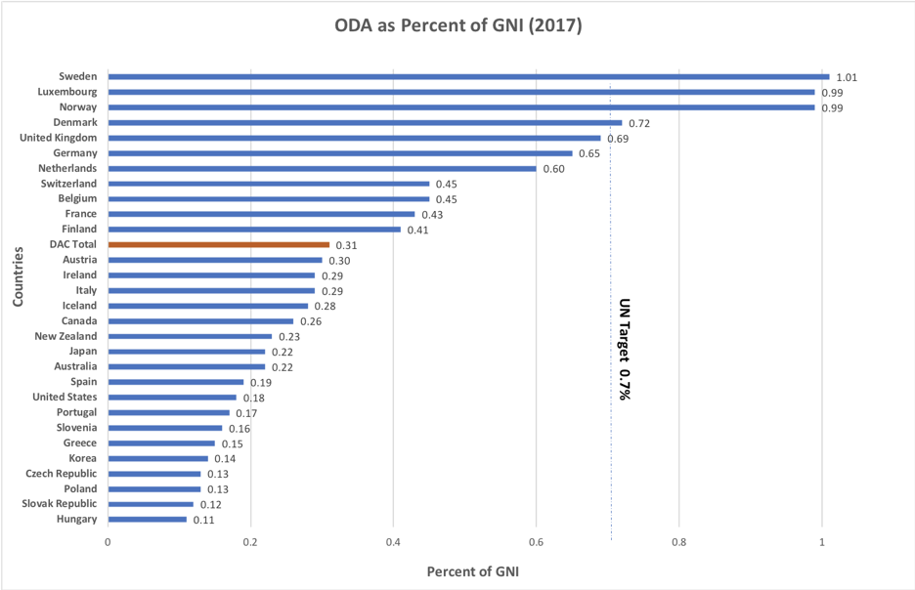
Figure 2. Only Sweden, Luxembourg, Norway, Denmark, and the United Kingdom have given approximately or above the UN target share of 0.7% of gross national income for Official Development Assistance. Source:

In the mid-1970s the developing countries led the call for a New International Economic Order (NIEO) that included higher prices for primary commodities and sufficient development assistance to end poverty. The NIEO was aggressively resisted by the United States and the initiative was completely abandoned by the early 1990s.

In 2002, following the adoption of the UN Millennium Development Goals, the UN member states agreed on the Monterrey Consensus, which called on developed countries:

that have not done so to make concrete efforts towards the target of 0.7 per cent of gross national product (GNP) as ODA to developing countries and 0.15 to 0.20 per cent of GNP of developed countries to least developed countries, as reconfirmed at the Third United Nations Conference on Least Developed 14 Countries, and we encourage developing countries to build on progress achieved in ensuring that ODA is used effectively to help achieve development goals and targets. (Paragraph 42)

In 2005, the G8 countries, meeting in Gleneagles, Scotland pledged to double aid to Africa by 2010 and to increase overall ODA by at least $50 billion by 2010. These Gleneagles commitments similarly were not met.

In 2015, in the leadup to the SDGs, the UN member states adopted the Addis Ababa Action Agenda on Financing for Development, similarly aimed to structure the financing of the SDGs. The Addis Ababa Action Agenda recognizes the need for increased financing in several priority areas, including: social protection and essential public services for all; scaled-up efforts to end hunger and malnutrition; bridging the infrastructure gap; sustainable industrialization; decent work for all; protection of ecosystems; and promoting peaceful and inclusive societies. It identifies action areas for financing, including: domestic public resources (mainly budget revenues); private business financing; and international development cooperation.

Poignantly, while the Monterrey Consensus had called on “developed countries that have not done so” to reach 0.7 percent of GNI in official development assistance, the Addis Plan merely reaffirmed the commitment by “many developed countries” to achieve 0.7 percent of GNI. The main reason for the change in language between 2002 and 2015 is that by 2015 the US Government had explicitly repudiated the intention to ever reach 0.7 percent of GNI in ODA. As of 2019, US official development assistance languishes at around 0.17 percent of GNI, roughly a shortfall of $100 billion per year from the US alone compared with the 0.7 standard.

The SDG Financing Shortfall

The stark reality is that the world’s low-income developing countries (LIDCs) cannot afford to finance the SDGs out of their own resources. A recent project in 2018 by the International Monetary Fund and the UN Sustainable Development Solutions Network (SDSN) 59 aimed to clarify the spending gap for the 59 LIDC countries eligible for IMF concessional assistance. These 59 countries include 1.7 billion people with per capita incomes generally below $1,700 per year (compared with average incomes in the developed countries of $40,000 or more). The world’s poorest countries are included in the LIDC group, and are highly concentrated in Sub-Saharan Africa.

The IMF study demonstrated that on average, the LIDCs would have to spend an additional 14 percent of the GDP in public outlays (that is, through budgetary expenditures) in order to meet SDG targets for health, education, water and sanitation, and electricity (Figure 3). On the other hand, these countries could only be expected to mobilize around 5 percent of GDP in additional budgetary revenues. The implication is a shortfall in budget financing on the order of 10 percent of GDP for the entire group of LIDC countries. In dollar terms, this shortfall amounts to $300 billion - $400 billion per year for the entire group of nations. The shortfall is even higher for the poorer countries within the group, because the increment in needed budget outlays is even larger than 14 percent of GDP.

Figure 3. Low-income developing countries need to spend additional 14.4% of GDP to achieve specific SDG targets. Source: IMF Staff Calculations.

The IMF helpfully put the shortfall in perspective by noting that $300 - $400 billion per year is on the order of a mere 0.9% of the combined GDP of the Advanced Economies (AEs) and 0.5% of World GDP. That is, the SDG financing shortfall for 1.7 billion people comes to less than one-half of 1 percent of world output! Yet raising that incremental sum, even such a modest proportion of global output, has proven to be impossible. The rich countries are instead turning their back on the poorest countries. The United States is worst in this regard, willfully cutting development aid despite being by far the largest rich nation in the world.

Case Study: The Fight Against AIDS, TB, and Malaria

The three epidemic diseases, AIDS, TB, and Malaria currently claim around 1.7 million lives per year, and the suffering of many more. Yet each of these epidemic diseases can be substantially controlled, bringing deaths to near zero. Scientific action plans have been identified for each of the three diseases to demonstrate how the epidemics could be decisively ended by 2030, in line with the aspirations of SDG 3, Healthy Lives for All.

The good news is that the cost of comprehensive control of the three diseases is not very high, roughly $101 billion for the three-year period 2020-22, or roughly $34 billion per year. The domestic budget revenues of the affected developing countries can provide around $46 billion of the needed $100 billion, leaving a three-year financing gap of around $55 billion. Of that amount, $37 billion is currently expected from existing donors during 2020-22, leaving a three-year funding gap of some $18 billion, or just $6 billion per year (Figure 4). Yet finding that $6 billion is proving to be extremely difficult, even though it marks an enormous difference in lives saved, new cases of the three diseases, and prospects for ending the epidemics.
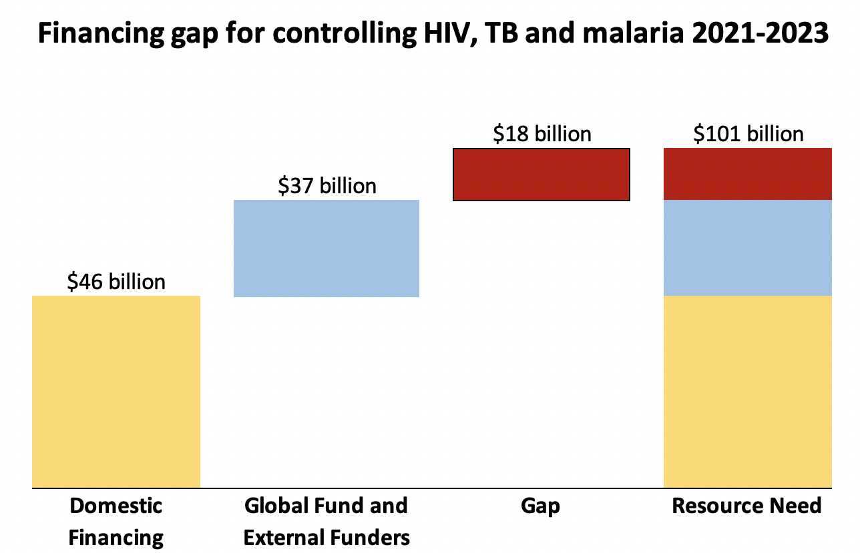
Figure 4. Domestic external financing expected for controlling HIV, TB and malaria in 2021-2023 leaves $18 billion financing gap, or $6 billion per year. Data adapted from The Global Fund’s “Investment Case Update” (January 2019).

The Wisdom of Saint Ambrose, the Major Faith Traditions, and Global Wealth Today

In his magisterial encyclical Populorum Progressio, Pope Paul VI wrote movingly and persuasively about the obligations of the rich to help the poor. The 1967 encyclical emerged during the UN First Decade of Development, in the period when dozens of former colonies in Africa and Asia were winning their political independence for the first time since the 19th century. Pope Paul VI called on the world to help these countries in justice, compassion, and mercy given their extreme poverty and high disease burden.
In this great encyclical, Pope Paul VI elucidates the Church’s doctrine of the Universal Destination of Goods, which holds that the world was created for everybody, not just for the rich. Human rights and dignity must take precedence over private property rights. Private ownership is never inviolate, but is instead subject to the moral law of universal dignity and human needs. In this context, Pope Paul VI quotes Saint Ambrose (born 339, died 397), one of the great Church Doctors, who said: "You are not making a gift of your possessions to the poor person. You are handing over to him what is his. For what has been given in common for the use of all, you have arrogated to yourself. The world is given to all, and not only to the rich.”
Pope Paul explains Saint Ambrose’s statement this way.
Private property does not constitute for anyone an absolute and unconditioned right. No one is justified in keeping for his exclusive use what he does not need, when others lack necessities. In a word, "according to the traditional doctrine as found in the Fathers of the Church and the great theologians, the right to property must never be exercised to the detriment of the common good". If there should arise a conflict ‘between acquired private rights and primary community exigencies’, it is the responsibility of public authorities ‘to look for a solution, with the active participation of individuals and social groups’.

The doctrine of the Universal Destination of Goods is more vital than ever today, because the global economy has created an astounding “winner-take-all” dynamic that is leading to unprecedented wealth accumulation among the world’s richest individuals. As Oxfam has demonstrated, the world’s richest 26 individuals have a combined net worth of $1.6 trillion dollars, equal to the combined wealth of the bottom half of the planet (3.8 billion people). Forbes Magazine has calculated that there are 2,208 billionaires (as of March 2018), with a combined net worth of $9.1 trillion. Jeffrey Bezos, founder and part owner of Amazon, has a net worth today (February 2, 2019) estimated at $135 billion. The number of billionaires tripled since 2000 and their estimated combined wealth, adjusted for inflation, increased roughly fivefold in just 18 years.
The billionaires might also reflect upon the Hindu tradition’s doctrine of renunciation. The first two verses of the Isha Upanishad read, “This entire universe, moving and unmoving, is enfolded in God. Renounce and enjoy” (Translation from the scholar Anantanand Rambachan). In other words, because the universe is a sacred reality, humanity is called to enjoy the planet, its resource, and any wealth derived from it, with open and generous hands. Exploitation and hoarding reflect a greed incompatible with charity, gratitude, and enjoyment of the planet’s bounty.

Distributive justice and compassion are similarly at the heart of Judaism, Islam, Buddhism and the other great world faiths. Jewish biblical law enjoins the landowner to set aside part of the harvest for the poor (Leviticus 23:22):

When you reap the harvest of your Land, you shall not completely remove the corner of your field during your harvesting, and you shall not gather up the gleanings of your harvest. [Rather,] you shall leave these for the poor person and for the stranger. I am the Lord, your God.

With its key concept of ‘interrelatedness,’ Buddhism also emphasizes the importance of compassion and donation. Acknowledging our interdependence with others promotes the virtues of compassion, self-giving, and generosity. The Buddhist tradition has also generated its own mode of economic reflection, which highlights simplicity, minimizing suffering and violence, and the simplification of desires, against the typical consumerism of modern economies.

In Islam, the practice of zakat, calls on those with incomes above a minimum to give a portion (often 1/40th) to the poor. Zakat is one of the five pillars of Islam, regarded as second in importance only to prayer. The word itself derives from “purification”: zakat constitutes a purification of one’s wealth through giving. Alms in this sense are given not only for the sake of the poor, but also for the moral and spiritual health of the one who gives.
Indeed, St. Ambrose’s vision of justice, applied to merely 2,208 people of the world’s 7.6 billion people, could readily solve the extreme deprivation of the world’s poorest 1.7 billion people. If the combined net wealth of the billionaires could be treated as an endowment put to work to fight extreme poverty, the $9.1 trillion would generate an annual flow of income of some $450 billion per year, assuming an annual payout rate of 5%. This sum exceeds the financing gap identified by the IMF for 59 low-income developing countries! The $450 billion, therefore, if well directed, could ensure universal basic health coverage, universal education through secondary school, the end of the three epidemic diseases, and access to clean water, sanitation, and modern energy services.

Part III. The SDGs and Six Deep Societal Transformations

According to the UN Sustainable Development Solutions Network, the 17 SDGs can most usefully be understood as requiring Six Transformations in society. These six transformations, if successfully achieved, would enable every part of the planet to achieve sustainable development, including the targets of the 17 SDGs.
Education, Gender, and Inequality

SDG 4 call on all countries to achieve universal secondary school completion by 2030. This will require increased investments in early childhood development and pre-K programs that have been shown to boost the cognitive and emotional development of children with persistent effects into adulthood. Pre-school education also helps reduce inequalities in opportunity among children. In parallel, countries need to ensure primary and secondary school completion for all, which inter alia will require enhanced teacher training and curriculum development.

Another pillar of this transformation is promoting gender equality (SDG 5) and social inclusion (SDG 10). Among others this will require measures to end discrimination in the workplace as well as other anti-discrimination policies and standards. Equal access to high-quality education, healthcare, and other services is of course critical for reducing inequalities, and needs to be complemented with social safety nets.

In addition to improved education, social safety nets, and anti-discrimination measures, improved labor standards form another pillar for reducing inequalities (SDG 10). The International Labor Organization (ILO) has developed detailed standards that every country and employers should meet. Of particular importance should be efforts to end all forms of modern slavery, trafficking, and child labor, which continue to be prevalent in poor and rich countries alike (SDG 8.7).

Health, Wellbeing, and Demography

The SDGs shift the focus towards universal health coverage (SDG 3) as well as the social and environmental determinants of health and well-being. They frame health as a basic need and a human right. A central pillar of the Health, Wellbeing, and Demography Transformation is universal health coverage (UHC), which will also contribute directly to SDG 5 (gender equality) and SDG 1 (no poverty). UHC requires a core publicly financed health system that integrates prevention, therapeutic, and palliative services. Health systems also require integrated information systems, real-time epidemic, and disease surveillance and control. In many countries community health programs have been shown to improve health outcomes significantly.

The health system must offer a range of health services. A critical priority are interventions for maternal, newborn, and child health. To control the spread of infectious diseases, health systems must offer effective prevention and treatment. And they need to integrate non-communicable disease control, including mental health and basic surgery.

Clean Energy and Industry

The world will require growing use of energy together with a decisive drop in CO₂ emissions. The climatology is clear. To have at least a two-thirds probability (a “likely” outcome) of remaining below 2°C in global warming requires that the cumulative net emissions of CO² in the 21st century should be no more than 600 Gt (Gigatons) of CO₂ (SDG 13). Yet the current emissions from energy use alone are on the order of 40 Gt per year, meaning that humanity has roughly 15 years remaining of energy-related CO₂ emissions at the current global rate. To the energy-related emissions we need to add the emissions due to land-use change, considered in the next transformation.

Available national and global pathways for decarbonizing the energy system suggest three major pillars for action. First, countries need to ensure universal access to zero-carbon electricity and other clean fuels (SDG 7). This will require a shift from fossil fuels (coal, oil, and gas) to zero-carbon sources, including wind, solar, hydro, geothermal, ocean, and others.
Second, countries need to improve energy efficiency in final energy use. This includes transport (e.g. lighter and more efficient vehicles, car sharing, autonomous vehicles), buildings (heating and cooling, thermal insulation), industrial energy use, and household appliances. Third, countries need to electrify current uses of fossil fuels outside of power generation, such as the internal combustion engine (through electric or hydrogen vehicles), boiler and heaters in buildings (through heat pumps), and various industrial processes, such as steel and cement production.

In addition to energy decarbonization, all nations must sharply cut industrial pollutants of the air, water, and land (SDG 12). Key industrial pollutants include methane, nitrous oxides, sulphur dioxide, as well as organic and other inorganic pollutants. Water management, life-cycle approaches, and other tools of circular economy can increase resource efficiency and lower pollution. The circular economy also provides a framework for 21st century industrialization strategies in sub-Saharan Africa and elsewhere.

Sustainable Food, Land, Water, Oceans

The fourth transformation is in land use and food systems. The current patterns of land use, mainly related to food production, are unsustainable three ways. First, today’s agricultural systems are major drivers of environmental change. They account for about a quarter of greenhouse gas emissions (SDG 13), over 90 percent of scarcity-weighted water use (SDG 6), and they are the major driver of biodiversity loss (SDGs 14 and 15), eutrophication through nutrient overload, and pollution of water and air. At the same time, the food system is vulnerable to environmental changes now underway, through the increasing severity of droughts, floods, disease, and land degradation caused, in part, by climate change. Similarly, most ocean and freshwater fisheries are overexploited. Finally, today’s food system does not produce healthy diets, leading to persistent hunger, wide-spread malnutrition, and a growing obesity pandemic.

The implications are clear. The world will need a major transformation of food systems and land-use to mitigate human-caused environmental degradation, build resilience into food production, and achieve better health outcomes. This in turn will require efficient and resilient agricultural systems, the conservation and restoration of biodiversity, a shift to healthier and more plant-based diets, and improved land-use regulation and management.

Smart Cities and Transport

Cities today are home to around 55 percent of humanity and 70 percent of global output. By 2050, cities will be home to around 70 percent of humanity and perhaps 85 percent of global output. What happens in cities, therefore, will determine the wellbeing of most of humanity and the prospects for sustainable development. It is therefore no accident that the world’s national governments assigned SDG 11 to sustainable cities, meaning cities that are economically productive, socially inclusive, and environmentally sustainable.

As a first priority, cities need to develop sustainable urban infrastructure. This includes an efficient transport system; universal access to reliable and low-cost electricity, safe water and sewerage; recycling and other sustainable waste management; high-speed and low-cost broadband connectivity to support businesses and public service delivery. These should be deployed according to a plan that takes account of likely population growth. Safe, open, green spaces, infrastructure for cycling and walking, and higher density settlements increase resource efficiency and quality of life. Smart urban networks can provide real-time monitoring and management of safety, traffic, energy use, and other services.

Digital Technology and E-Governance

The greatest single technological enabler of sustainable development in the coming years will be the digital revolution, constituted by the ongoing advances in computing, connectivity, digitization of information, and machine learning, robotics, and artificial intelligence (AI). The digital revolution rivals the steam engine, internal combustion engine, and electrification for the pervasive effects on all parts of the economy and society. The rapid pace of advance continues, with imminent breakthrough prospects for AI, quantum computing, virtual reality, 5G broadband, and other technologies.

- Universal access to high-quality, low-cost mobile broadband
- Digital transition and connectivity of all government facilities
- Online national systems for healthcare and education
- Online e-finance and e-payments to facilitate trade and business services
- Universal online identify for official purposes (banking, taxation, registration, etc.)
- Regulatory security for online identity and privacy
- Income redistribution to address income inequalities arising from digital scale up
- Tax and regulatory systems to avoid monopolization of Internet services
- Online data governance and interoperability provisions
- Democratic oversight of cutting-edge digital technologies

Part IV. The Decisive Role of Multi-Religious Action to Achieve the SDGs

Multi-religious action is essential to achieve the SDGs. Every major religion is committed to the core values espoused by the SDGs: human dignity and flourishing, the rights of the poor, and social justice and peace. Every major religion has unique and significant assets to bring to the fulfillment of the SDGs, including a profound code of ethics, a daily dialogue with all parts of society, face-to-face engagement with billions of people around the world including the world’s poorest people, vital institutions of education, health, charity, environmental protection, and the ability to teach and disseminate the vital information needed for global success in sustainable development. I briefly summarize some of the key practical pathways for religious engagement with the SDGs.

Ethics in Action

The world’s major religions are the repositories of humanity’s core moral codes and ethical guideposts. Fortunately, there is a deep congruence among the religions in the core ethical precepts regarding human dignity, the rights of all people to meet basic needs, the essential value of compassion and service to others, and respect and stewardship of the natural environment. The Ethics in Action initiative, hosted by the Chancellor of the Pontifical Academy of Sciences, Bishop Marcelo Sanchez Sorondo, and with the partnership of several faith groups led by Religions for Peace, demonstrated the ability of a multi-faith leadership group to formulate agreed ethical principles and guidelines for action to achieve the SDGs. This multi-faith consensus should now be further strengthened and broadened, so that religious leaders across all major faiths and regions become leaders of the SDGs in line with the deep teachings of their respective faiths.

Religions and Multi-Stakeholder Engagement

Religious communities can convene the key stakeholder groups in society needed to achieve the SDGs. The Catholic Church has, for example, marvelously convened scientists, mayors, judges, ethicists, and faith leaders of many religions to support integral and human development, guided by Pope Francis’s call for a common plan for our common home in his magnificent encyclical Laudato Si’. The Pontifical Academy of Sciences played a decisive role in gathering experts to support the SDGs and Paris Climate Agreement, and the Pope Francis played a key role in helping to build a global consensus around both the SDGs and the climate agreement. Other religions are now convening religious leaders and scientists together work hand-in-hand on sustainable development initiatives, with powerful benefits for society.

Work with Local Congregations
Achieving the SDGs will require that people around the world know of the goals and understand their relevance and potential benefits for their own families, communities, and nations, as well as for the world. The SDGs should be explained from the pulpits of all faiths, to help all of humanity to understand their human rights and the global quest to end poverty, promote social justice, and protect the natural environment.

Direct Service Provision

All major faiths play a vital role in direct service provision, for education, healthcare, and social support services, often with special attention to the most vulnerable, including the young, the elderly, the disabled, migrants, minority groups, and the marginalized. As such, the religious communities strive to live the faith of “leave no one behind,” even when societies are misguided enough to cast the vulnerable aside.

The SDGs are first and foremost about vital social services for all, including social protection for the extreme poor (SDG 1) and the hungry (SDG 2); healthcare for all (SDG 3); education for all (SDG 4); water and sanitation for all (SDG 6); and modern and safe energy services for all (SDG 7). Religious providers of these social services should team up with governments and international donor agencies in a systematic way to ensure that the universal aspirations of the SDGs (truly leaving no one behind) can be successfully fulfilled.

Public Education and Awareness

As Pope Francis has frequently reminded us, our greatest vulnerability today is the “globalization of indifference,” meaning the fact that humanity is neglecting even its own survival. We are lost in a world of online imagery, substance and behavioral addictions, political demagoguery, commercial distractions, and rampant consumerism to the point that we neglect the essential needs of our communities, much less the needs of the poor and vulnerable. We are manipulated by fear rather than inspired by compassion.

The world’s religions have a unique role to play in overcoming the globalization of indifference, by joining together in the clarion call for human survival and wellbeing; by demonstrating the common bonds across races, religions, classes, and ethnicities; by proving through their good works the ability of our societies to leave no one behind.

In Laudato Si’, Pope Francis invited a dialogue among all people, believers of all faiths and non-believers alike, in search of a path to authentic human and sustainable development. He noted that our interdependence obliges us to search for a common plan for humanity and the planet. By raising the voices of all of the world’s great faiths in unison, the multi-faith community will be able to overcome the indifference that holds us hostage, drown out the haters and the fearmongers, and open the way to a new generation of collection action for the common good that will inspire people around the world.

The United Nations Sustainable Development Solutions Network, an initiative under the auspices of UN Secretary-General Antonio Guterres to support the Sustainable Development Goals (http://www.unsdsn.org)

