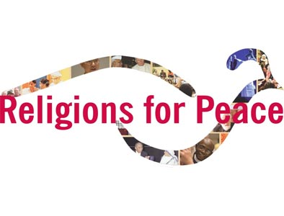
Statement on Welcoming Each Other: from Fear to Trust

Statement from the closing Plenary of the
General Assembly of Religions for Peace Europe, October 31, 2015.

Castel Gandolfo, 1.11.2015

Believing in Peace - Building Trust, not Fences - Improving Integration and Dialogue - Welcoming Diversity - Achieving Solidarity

Being aware of the particular responsibility of European political and religious institutions in the current political, economic and social challenges to our continent,

Inspired by our religious values of peace, love and hope and deeply committed to Europe's core political principles of freedom, justice, equality and solidarity

the Religions for Peace European Assembly, gathered at Castel Gandolfo (Italy), 28 October - 1 November 2015, urges European political decision-makers, particularly European Union institutions such as the European Council, the European Commission and the European Parliament,

- to substantially engage in foreign policy dialogue with other major international powers such as the United States, Russia, Turkey, Iran, Saudi Arabia and other actors involved to overcome civil wars, violence and ethnic and religious cleansing in Africa, Asia and the Middle East thus ending the main reasons for refugees to flee their countries of origin
- to further develop the United Nations conventions and international agreements on limiting arms trade and proliferation and to create a clear legal base in European Union primary law to prohibit all arms exports from EU member states to outside EU / NATO areas or outside UN mandated interventions and to monitor this at European and national level
- To reform the EU laws on refugees and asylum-seekers and to adapt them to better respond to the current crisis and to uphold the fundamental right of asylum in Europe
- to substantially increase the EU's and EU member states' funding for the UNHCR, ECHO and other organizations, including faith-based charities, helping immigrants and refugees in Europe and in the host countries of the affected regions, notably in Turkey, Lebanon and Jordan
- to significantly increase funding for intercultural and interfaith dialogue initiatives and projects, for example within the framework of the EU Structural and Social Funds, and to further expand and improve existing EU programs to support the integration of immigrants and Europeans with a migration background
- to double the EU funding for fighting youth unemployment in Europe, with a particular focus on less favored young people in danger of being discriminated because of their ethnic or religious background
- to increase financial support of the EU and EU member states for projects and initiatives combating discrimination, xenophobia, anti-semitism, islamophobia and religious hatred at European, national, regional and local level in order to help people to turn fear into trust, to foster open mindedness to people from different countries, diverse ethnic and religious backgrounds and to respect the human dignity of each person.

